Plaque Information - Tara and District Cemeteries

What sort of plaque can I have?
Council's standard plaque is cast bronze. A variety of size and design options are available for memorial plaques in the Chinchilla, Tara and Miles Cemeteries and Council is responsible for the procurement of such. (There are a number of older plaques in the cemeteries that are black and white or chrome - these are no longer manufactured however where possible a second inscription can be arranged.)

Tara Lawn and General Cemeteries
- Grave - 380 x 230mm, choice of shape and colour, Roman or Helvetica font, choice of border around plaque.
- Columbarium Niche - 285 x 265mm, choice of colour, Roman or Helvetica font, choice of border.

Meandarra Cemetery
- Grave - 380 x 230mm, choice of shape and colour, Roman or Helvetica font, choice of border.
- Columbarium Niche - 285 x 265mm, choice of colour, Roman or Helvetica font, choice of border.

Moonie Cemetery
- Grave - 380 x 230mm, choice of shape and colour, Roman or Helvetica font, choice of border.

Who can organise a plaque?
All lawn cemetery plaques must be arranged by Council. Only the burial rights holder is authorised to request Council to arrange for the plaque unless written authorisation is provided. Should the right of burial holder pass away, then the right of burial becomes part of his or her estate to be administered by his or her executor. If there is no executor then the "major beneficiary", next of kin or enduring power of attorney may take charge, although they will have to provide documentation to support their claim.

How much does a plaque cost?
This is dependent upon a number of factors such as the need for second inscription vs a new plaque, amount of wording and emblems etc. All fees payable are required to be remitted to Council prior to a plaque being manufactured.

Can I put a photo on the plaque?
Council can arrange for a photo to be attached only in the instance where we are arranging for the manufacture of a whole new plaque. Customers are requested to supply a high quality photo that can be scanned to our supplier. Alternatively a high quality digital image in jpeg format can be e-mailed to Cemetery staff.

What happens after I lodge my application?
Your request will be provided to Council's supplier so that a proof can be generated. Cemetery staff will arrange to forward the proof to you for consideration and request signed authority to proceed with manufacture and acceptance of costs. Two copies will be provided - one with stamped customer authority to sign and one without. Customers are required to carefully review the proof, ensuring that all typography is correct and no errors have occurred particularly with names and dates. Once a plaque is manufactured we are unable to correct mistakes.

How long does it take?
From start to finish - allow up to (approx.) three months.

Do I have to use your suggested wording?
Absolutely not. In fact Council encourages all customers to take their time in preparing the application form and encourage you to take a walk through the cemetery to reflect upon the wording that other customers have used.

Refurbishment of older plaques?
Unfortunately, over time plaques may become dull and weathered. Customers may request Council arrange for their refurbishment which will be at their cost.

Niche Sizes

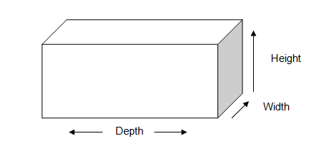
Cemetery | Height | Width | Depth
Tara Cemetery | 108mm | 106mm | 203mm
Meandarra Cemetery | 108mm | 106mm | 203mm

