Local Housing Action Plan 2023
Queensland Housing Strategy 2017-2027

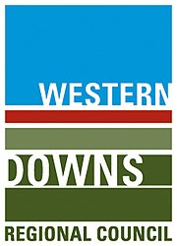

Contents
1.0 Executive Summary 4
2.0 Introduction 4
2.1 Local Housing Action Plan 4
2.2 Approach and Methodology 5
2.3 Western Downs Regional Futures Summit 5
2.4 Emerging Issues 6
3.0 Key Facts 8
3.1 The Western Downs Region 8
4.0 Key Characteristics of Western Downs 9
4.1 Key Demographic Characteristics 9
Demographic and household data Snapshot by Town 9
4.1.1 Population 10
4.1.2 Age 10
4.1.3 Household Composition 11
4.1.4 Family Incomes 12
4.1.5 Migration 14
4.1.6 Other Characteristics 14
4.2 Housing Characteristics 17
4.2.1 Dwelling Structures 17
4.2.2 Private Rental Market 19
4.3 Western Downs’ Housing Need 19
4.4 Barriers to New Housing Supply 21
5.0 Key Focus Areas 23
5.1 Land and Property 23
5.1.2 New Stock 23
5.1.3 Existing Stock 23
5.2 Housing Diversity 25
5.3 Workers Accommodation 25
5.4 Social Housing 27
5.5 Cohort Specific Housing 28
5.5.1 First Nations 28
5.6 Improved Data and Analysis of Need 28
6.0 Response Opportunities 29
6.1 Actions 30
6.2 Next Steps 37

Partnership Acknowledgement

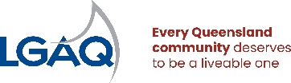

The Western Downs Regional Council (WDRC) Local Housing Action Plan was developed with the support of the Queensland Government in association with the Local Government Association of Queensland.

Acknowledgment of Country
Council respectfully acknowledges the traditional owners, the Barunggam, Iman (Yiman), Bigambul, Wakka Wakka, and the Jarowair people, as the custodians of this land. We pay respect to all Aboriginal community Elders, past and present, who have resided in the area and have been an integral part of the region's history.

Disclaimer
The Western Downs Regional Council Local Housing Action Plan is a non-statutory plan and ‘living document’ prepared under the Queensland Housing & Homelessness Action Plan 2021-2025 (Action 5) to support local housing outcomes. This Local Housing Action Plan is not the same as a Housing Strategy under the State Planning Policy, or a housing study, but may inform statutory documents like a planning scheme.

Version Control
This document was endorsed by Western Downs Regional Council at it's Ordinary Meeting on 15 February 2024.

Executive Summary

2.0 Introduction
The Queensland Housing Strategy 2017-2027 (the Housing Strategy) sets out the 10-year vision for the state’s housing system and the Queensland Government’s commitment to make sure all Queenslanders have a pathway to safe, secure and affordable housing.
The Housing Strategy demonstrates the Queensland Government’s plan to work with communities, industry and the housing and homelessness sector to deliver more social and affordable homes and better services for vulnerable Queenslanders. Delivered through multiple action plans, the Housing Strategy drives ways of working across government and the sector, delivering more social and affordable homes and an integrated system where people can access housing with support according to their needs.
On 15 June 2021, the Queensland Government launched the Queensland Housing and Homelessness Action Plan 2021-2025 (the Action Plan) – a four-year plan to deliver the next stage of the Queensland Housing Strategy 2017-2027. Action 5 of the Action Plan commits the Queensland Government to work with regional councils to increase and diversify the supply of housing, including opportunities for alternative government and non-government investment incentives.
This includes working with regional councils to develop a Local Housing Action Plan (LHAP) to understand key local issues and work in partnership to prioritise key issues and to develop operational arrangements that enable targeted housing outcomes. This will be an iterative process to improve the availability, diversity and quality of housing overtime and encourage community liveability, resilience and social and economic growth and prosperity. This supports the Queensland Government’s objective to grow Queensland’s regions by attracting people, talent, and investment, and driving sustainable economic prosperity. In addition, supporting local governments and local communities to identify key housing needs and opportunities to partner with all levels of government and private sector to support housing delivery.

2.1 Local Housing Action Plan
This LHAP is developed through a joint initiative involving the Queensland Government, Western Downs Regional Council (WDRC) and the Local Government Association of Queensland (LGAQ) to respond to a range of immediate, emerging, and longer-term housing challenges in the Western Downs region.
This is an iterative process (Figure 1) that does not intend to duplicate existing actions of WDRC or the actions under the Queensland Housing Strategy 2017-2027 or the Housing and Homelessness Action Plan 2021-2025. It seeks to identify opportunities, consider an agreed response, develop targeted actions on key priorities and enable ongoing review of efforts to adapt and respond to changing need.
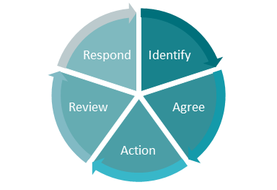
Figure 1: The Local Housing Action Plan Iterative Process

The Plan aims to:
- Develop agreed priority actions to respond to local housing needs.
- Establish strong foundations for longer-term housing responses to assist housing and homelessness outcomes in the Western Downs region.
- Incorporate existing information and plans that assist with developing responses to housing needs and acknowledge work already completed by WDRC The Queensland Government, private and not-for-profit organisations.
- Facilitate targeted interaction between all parties through agreed actions to ensure a focus on deliverables and projects that can improve housing responses in the short and longer term. Approach and methodology.
This Plan is initially focused on actions from 2024 to support a strong response to emergent housing need that support better housing outcomes into the future.

2.2 Approach and Methodology
The Plan provides an overview of key community and housing characteristics, and emerging issues related to housing in the community and identifies a targeted initial set of priority actions to respond to local housing need. It has been developed through a review of a range of supporting documentation including:
- Western Downs Regional Council Corporate Plan 2021 - 2026.
- Western Downs Regional Council Planning Scheme 2017.
- Western Downs Regional Council Economic Development Strategy 2023 - 2028. economic-development-strategy-document-ver-22.02.23.pdf (wdrc.qld.gov.au)
- Western Downs Regional Council Communities Partnering Framework.
- Other relevant Council strategies, reports and plans.
- Statistical data from the Queensland Government Statisticians Office and the Australian Bureau of Statistics including Census and other data sets such as building approvals, rental market data and housing approvals.
- Housing needs data from the Department of Housing and other state agencies as required.
- The Queensland Housing Strategy 2017-2027 and the Queensland Housing and Homelessness Action Plan 2021-2025.
- Other local data and information provided by the council.
Emerging issues and opportunities, key challenges and potential responses have been developed from the review of a range of data sets, anecdotal feedback, and preceding engagement opportunities with WDRC and other stakeholders. A key stakeholder engagement opportunity was undertaken by WDRC at the Western Downs Regional Futures Summit which is detailed in the following section.

2.3 Western Downs Regional Futures Summit
The Western Downs Regional Futures Summit was held on 3-5 May 2023, at the Dalby Events Centre. It was attended by 102 people from the community, local industry, services, and government stakeholders. Collaboration for Impact facilitated the workshop with the following key objectives:
- To strengthen collaboration by building on the existing partnering across the region;
- To leverage the diversity of the communities across the region to maximise outcomes for all;
- To develop a shared understanding of what it will take to make things better across the region; and
- To define what we need to continue to discuss and how we will govern this at this early stage.
From the first day, housing was nominated as the top priority area that the community could collaboratively work on together. Through the discussions across the summit, the team identified actions flowchart to work on several initiatives, including the LHAP. Several key themes were identified from the summit including challenges with delivering housing diversity, availability of trades and financial barriers. Further details and insights from the summit are outlined in relevant sections throughout this Plan.
Western Downs Futures continues as a place based collaborative impact strategy for the Western Downs Region. It is auspiced by Council with community and industry stakeholders, with local and state government support to enable progress for the region.

2.4 Emerging Issues
In recent years, the Western Downs Region has been affected by events requiring emergency responses. These include floods and fires of significant scale, resulting in the displacement of residents from homes across the region. In response to the housing priority of the Western Downs Future’s summit and through the relationships made in the development of this LHAP – the Western Downs Regional Council and the State government have worked in collaboration to undertake immediate emergency and long-term housing initiatives.
These include:
- Redevelopment of the Tara Caravan Park to address immediate emergency housing
- Identification of social housing sites
- Feasibility review on additional council-owned sites for potential future residential use
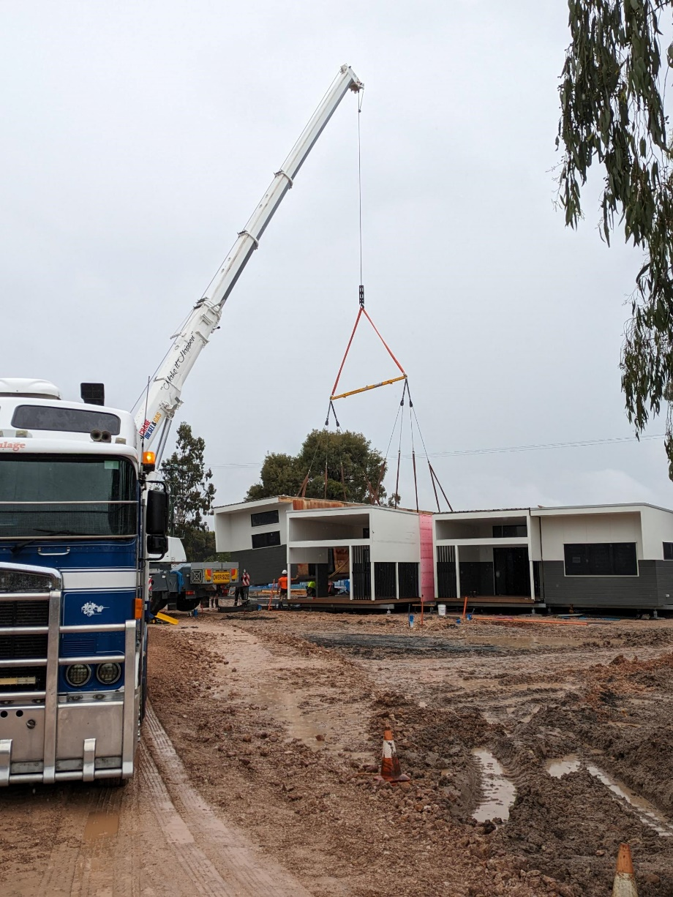
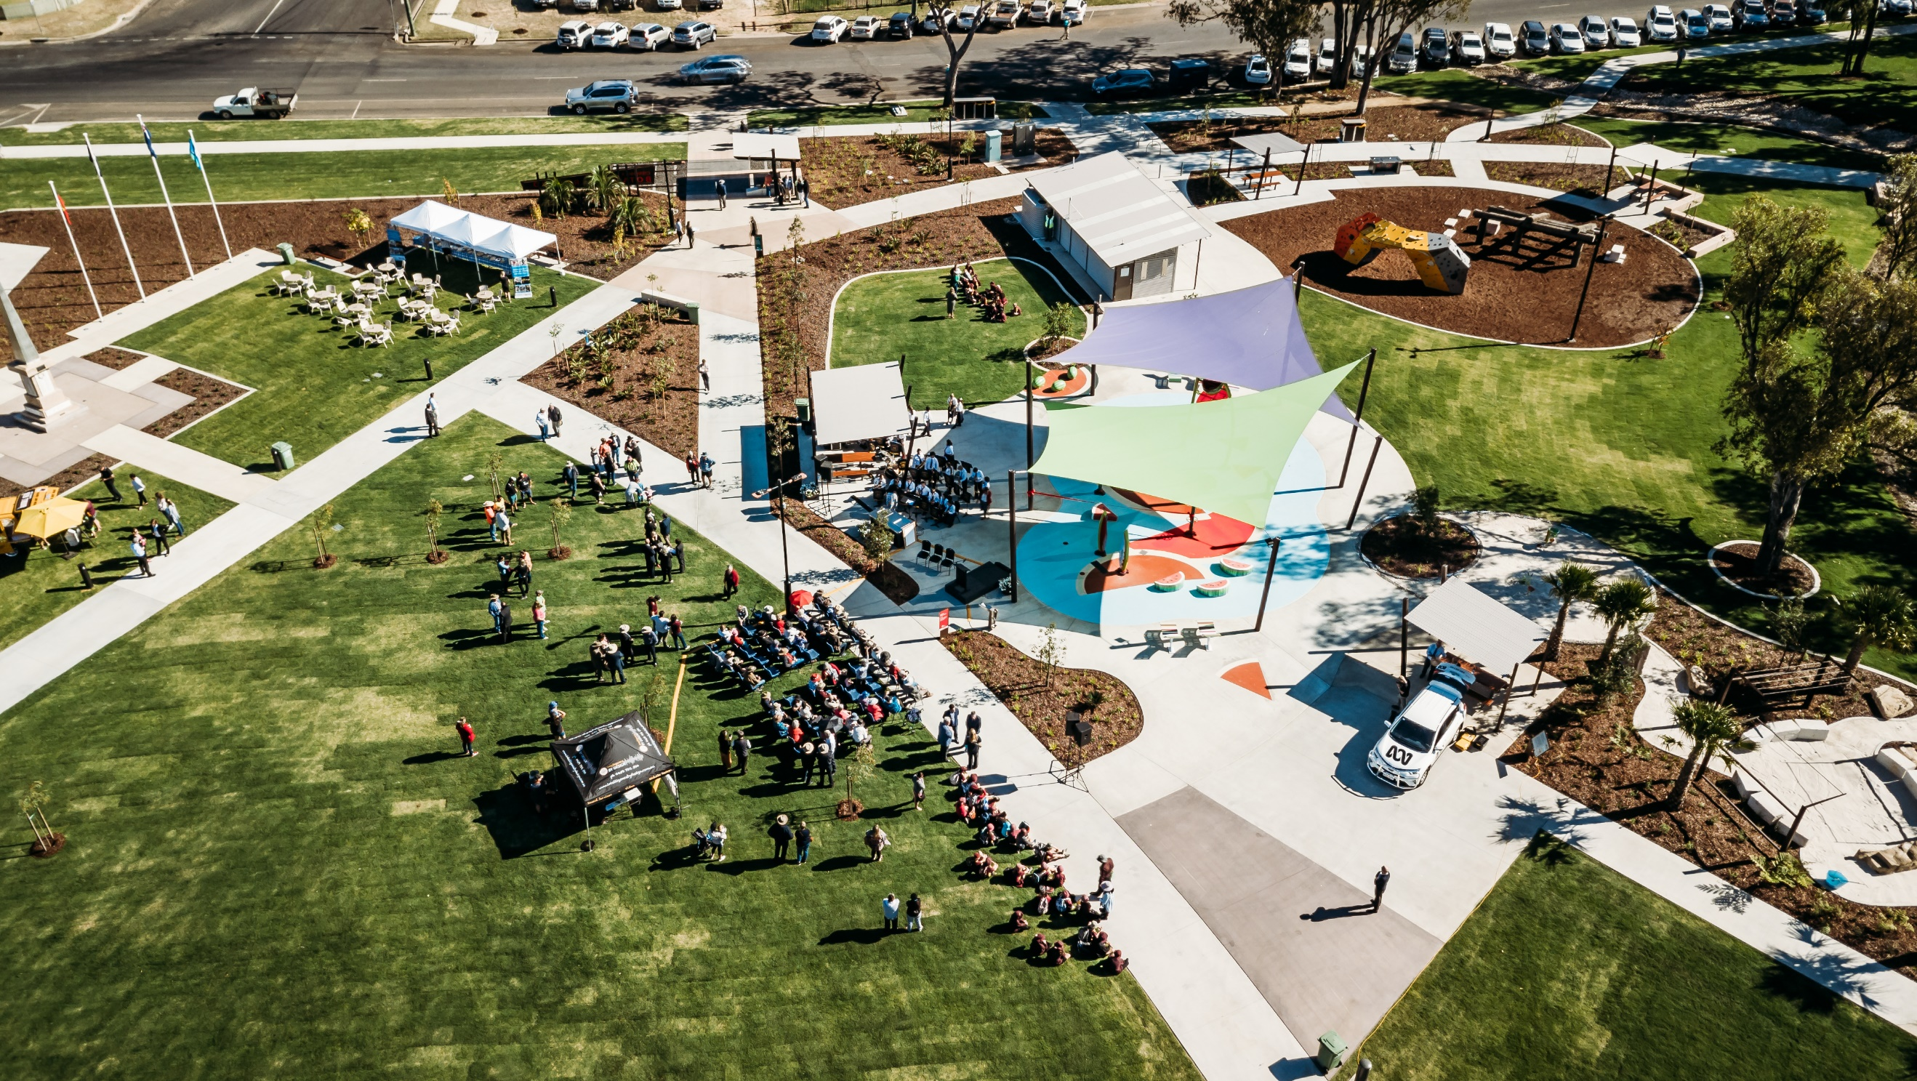

Western Downs Futures supplements the Queensland Energy & Job Plan, which will rely heavily on the Western Downs leading the energy transformation.
This plan relies on attracting and retaining people tour, as well as ensuring adequate housing, health, childcare, and services, which is why it's vital we come together to define a shared vision and dedicated course of action as one community.
- Mayor Paul McVeigh

3.0 Key Facts

3.1 The Western Downs Region
The Western Downs region covers an area of 37,937km², with a population of 34,584 people. The region includes 6 townships Dalby, Chinchilla, Dalby, Jandowae, Miles, Tara and Wandoan. The traditional lands of the Barunggam, Iman (Yiman), Bigambul, Wakka Wakka and Jarowair peoples.
Located two-and-a-half hours from Brisbane, and an hour from the Toowoomba Wellcamp Airport, the Western Downs offers the best of both worlds- a regional lifestyle without the loss of amenities. The Western Downs region is experiencing increasing migration from metropolitan areas and abroad, taking advantage of the growth and development opportunities right across the four pillars of the diverse regional economy: Agriculture, Intensive Agriculture, Manufacturing and Energy Sectors.
Located in the heart of the Surat Basin, the Western Downs has a diversified energy portfolio with five pillars of energy generation, which have had significant investments over the past 15 years: Coal, Gas, Hydrogen, Wind and Solar, cementing it as the Energy Capital of Queensland. Significant industry developments between 2006 and 2011 resulted in strong population growth (2.1% p.a).
The Western Downs is located at the heart of the Southern Queensland Renewable Energy Zone, and as indicated by the Queensland Energy and Jobs Plan and Blueprint, is in the first phase of further renewables development.
Strong industry growth is paired with a sustainable and long-term increase in our critical services. Local employment increased between 2016 to 2022 by10.7% in retail, 7.7% in health care and social assistance, 7.2% in education and 5.7% in public administration . ￼ The long-term demand for housing is rapidly increasing The physical extent of the Western Downs region is shown in Figure 2.
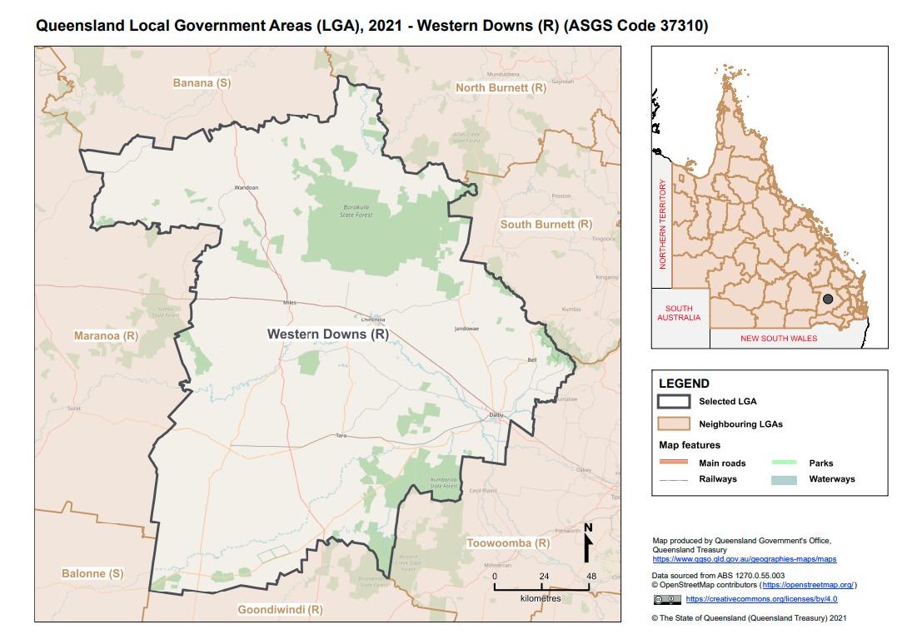
Figure 2: Western Downs Region ASGS 2021

4.0 Key Characteristics of Western Downs

4.1 Key Demographic Characteristics
Demographic data included in this Plan for the Westerns Downs Local Government Area, is based on Australian Bureau of Statistics (ABS), Australian Statistical Geography Standard (ASGS), July 2021 and is primarily sourced from the Queensland Government Statistician’s Office (QGSO) Queensland Regional Profiles for Western Downs Local Government Area (LGA) (ASGS 2021).
Where relevant, data comparisons are made to Queensland (State) data sets. References from these sources to ‘Western Downs’ will generally refer to the region. Statistics provided are based on available statistical data, where information from the 2021 Census is available, these figures have been included in this social baseline. Localised data sources have been used if more recent than 2021 ABS & QGSO data. Localised data has been sourced from .id (informed decisions) to prepare more localised data projections and housing profiles which have been used to inform the WDRC Local Housing Action Plan.

4.1.1 Key Demographic and Household Data Snapshot by Town
Overall housing need across each town varies and the disparity of financing for housing between some towns.
Whilst housing prices are relatively affordable, particularly in some of our smaller towns, it appears that banks may request a deposit of up to 40% to secure a home loan.
Table 1 – Snapshot of six towns in the region.
Town | Population | Average Age | Median Household income (weekly) | Median weekly rent | Median monthly mortgage repayments | Rental Stress (more than 30% of household incomes). | Mortgage Stress  (more than 30% of household incomes).
Chinchilla | 7,068 | 35 | $1,549 | $250 | $1,314 | 19.4% | 8.3%
Dalby | 12,758 | 35 | $1,462 | $260 | $1,300 | 24.8% | 7.5%
Jandowae | 1,004 | 53 | $959 | $200 | $940 | 24% | 11.8%
Miles | 1,874 | 38 | $1,334 | $200 | $1,018 | 12.2% | 9.6%
Tara | 1,980 | 48 | $867 | $180 | $758 | 20.2% | 12.3%
Wandoan | 666 | 31 | $1,243 | $160 | $712 | 10.6% | 36.4%

4.1.2 Population
The Western Downs Regional Council population is forecast to grow to 36,999 by 2046 (QGSO medium series), which represents a 6.75% increase from 2023 to 2046.
The Western Downs region has seen steady population growth since 2011 with the population increasing from 31,591 (year) persons to 34,659 in 2023. When looking forward at population projections in the region, it is estimated that there will be a steady increase of approximately 6.75% from 2023 to 2046. This will see approximately 36,999 persons living in the region by 2046 (see Figure 3).

Figure 3: Population forecast from 2021 to 2046

First Nations
The Western Downs Region has a population of 2,585 Aboriginal and Torres Strait Island Peoples, representing 7.6% of the total population, compared to 4.6% in Queensland.
There are town protocols that are in use which is Welcome to Country and Acknowledgement Protocol.

4.1.3 Age
Over the past 10 years, the median age has been consistently 38 years. . Over 50% of the Western Downs population is aged under 44 years. Refer to the township data comparison as this highlights that not all townships have this same age distribution. (see Figure 4).
The median age for Western Downs is 38 years.
Figure 4: Age breakdown of persons in the Western Downs region in 2021
By 2046 20% of the population will be over 65 years of age.
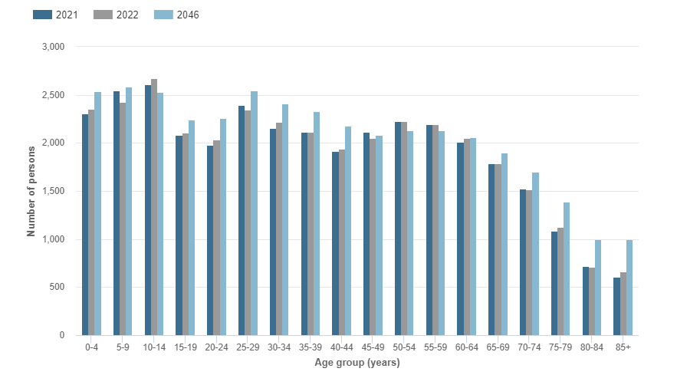
Figure 5: Forecast age structure (5-year age brackets) from 2021 to 2046

4.1.4 Household Composition
The majority of households in the Western Downs region (70%) are families. (see Figure 6).
When looking to the future composition of households within the Western Downs region, it is projected that demand for small households will increase at a higher rate than larger households. It is evident that this will increase the demand of smaller homes more diverse range of housing stock to accommodate lone persons and couples, including units, townhouses.
48%
26%
49%
180%
81%
6%
% increase:
Figure 6: Household Composition (2011 to 2046)

4.1.5 Family Incomes
From 2006 to 2021 incomes have risen to match the percentage growth across Queensland.
Between 2006 and 2021 the weekly household income has risen from $882 to $1,369 per week, compared to Queensland average, $957 in 2006 to $1,949 in 2021(see Figure 7).
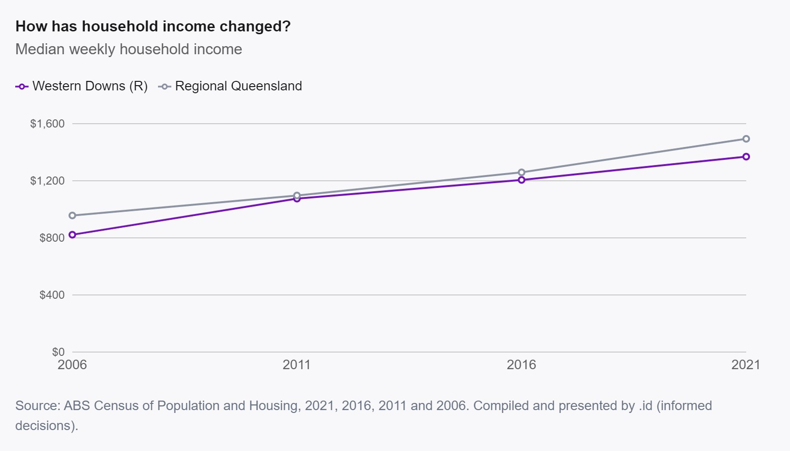
Figure 7: Median weekly household income trends (2006 to 2021).
The latest rental data from June 2023 shows the median rent for a house to be $400/week, which is significantly less than the Regional Queensland price point of $500/week (see Figure 8). The median unit rent is $270/week which is significantly lower than Regional Queensland of $420/week.
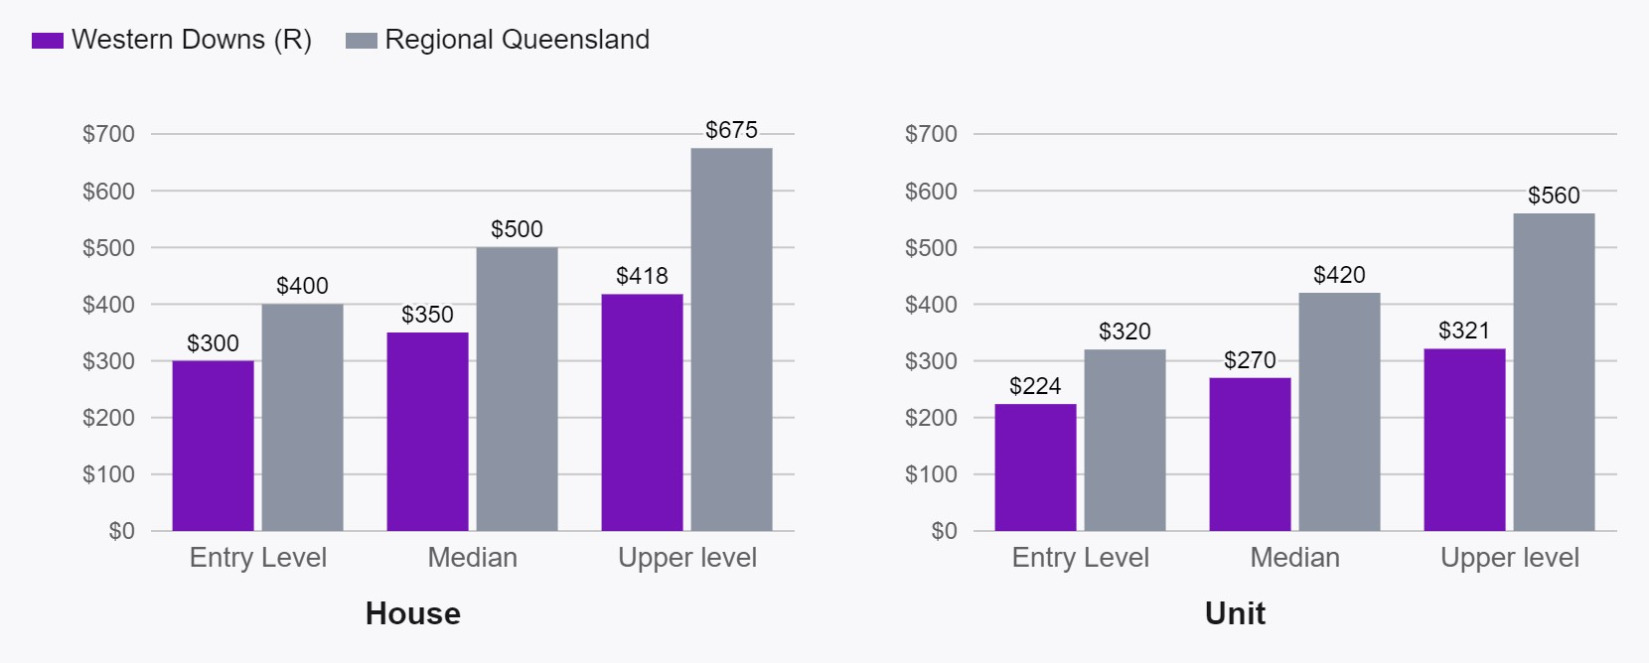
Figure 8: Median house and unit prices quarter ending December 2022
Rental prices have continued to rise to 2023. (see Figure 9).
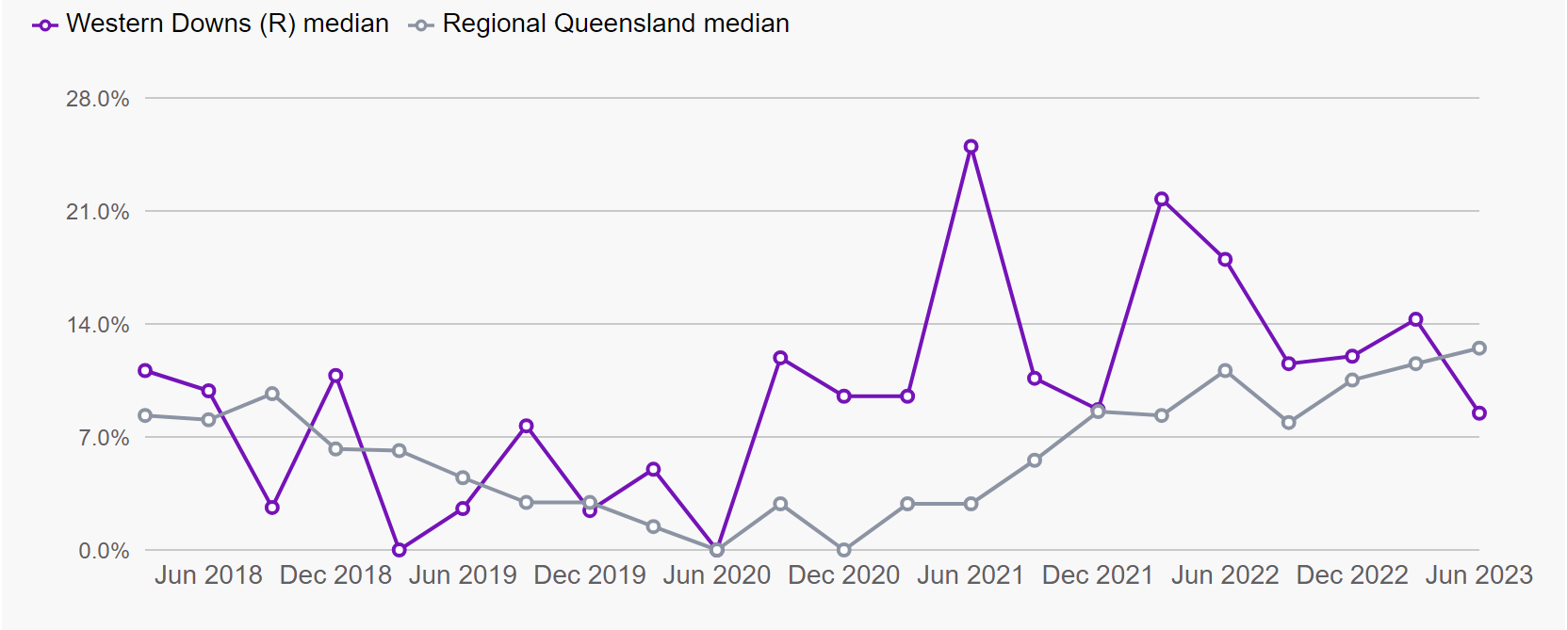
Figure 9: Annual average change in median rental listing June 2018 – June 2023

4.1.6 Migration
The Western Downs region had a steady population from the early 2000s, up until the commencement of significant coal seam gas (CSG) projects around 2006. From a stable population base up to 2006, the growth of coal seam gas (CSG) after this resulted in an increase of migration from inter and intra state and international residents between 2007 and 2014. Immigration growth started to slow following 2014 as the construction phase of the CSG projects came to an end. When looking to the future of the region, it is predicted that the age group with the highest net migration from the Western Downs Regional Council is 20–24-year-olds. This is forecasted to occur at the highest peak during 2021 to 2026 (see Figure 11).
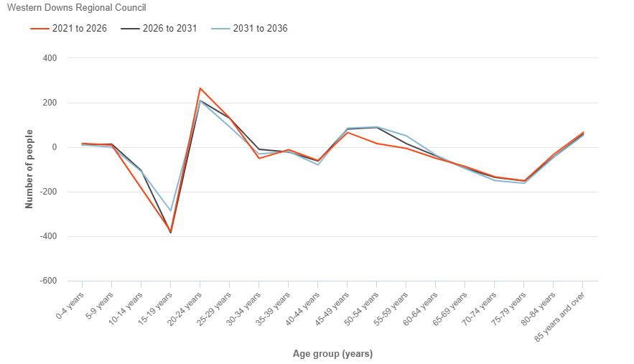
Figure 1011: Forecast net migration by age group.

4.1.7 Other Characteristics
There are a variety of different factors that make up each community, which add elements of diversity, opportunity and prosperity. These features include cultural backgrounds, language spoken at home, employment levels, access to social services payments and need for assistance due to disability or illness.
Cultural Backgrounds
18.1% of the population in the region identifying as being born overseas, which is not dissimilar to the Queensland average compared to 22.7% in Queensland. 5.3% stated they speak a language other than English at home compared to 15.6% for the state.
Health and Disability
The community also identified 6.4% of the population were persons who have a need for assistance with core activities (compared to Queensland’s 5.2%) and a further 7.1% identifying as having other long-term health conditions

Unemployment
The unemployment rate in the Western Downs region was 4.7% compared to Queensland at 3.8 %, as of March Quarter, 2023. This accounted for 870 unemployed people out of a total of 18,511 labour force . In 2021, there were 1,474 recipients on Jobseeker arrangements in the region
Homelessness
As of 2021 Census data 121 people experienced homelessness in the region. 12.4% of people were living in improvised dwellings, tents or sleeping out and 7.4% in supported accommodation and the remainder staying in temporary accommodation or living in severely crowded dwellings.

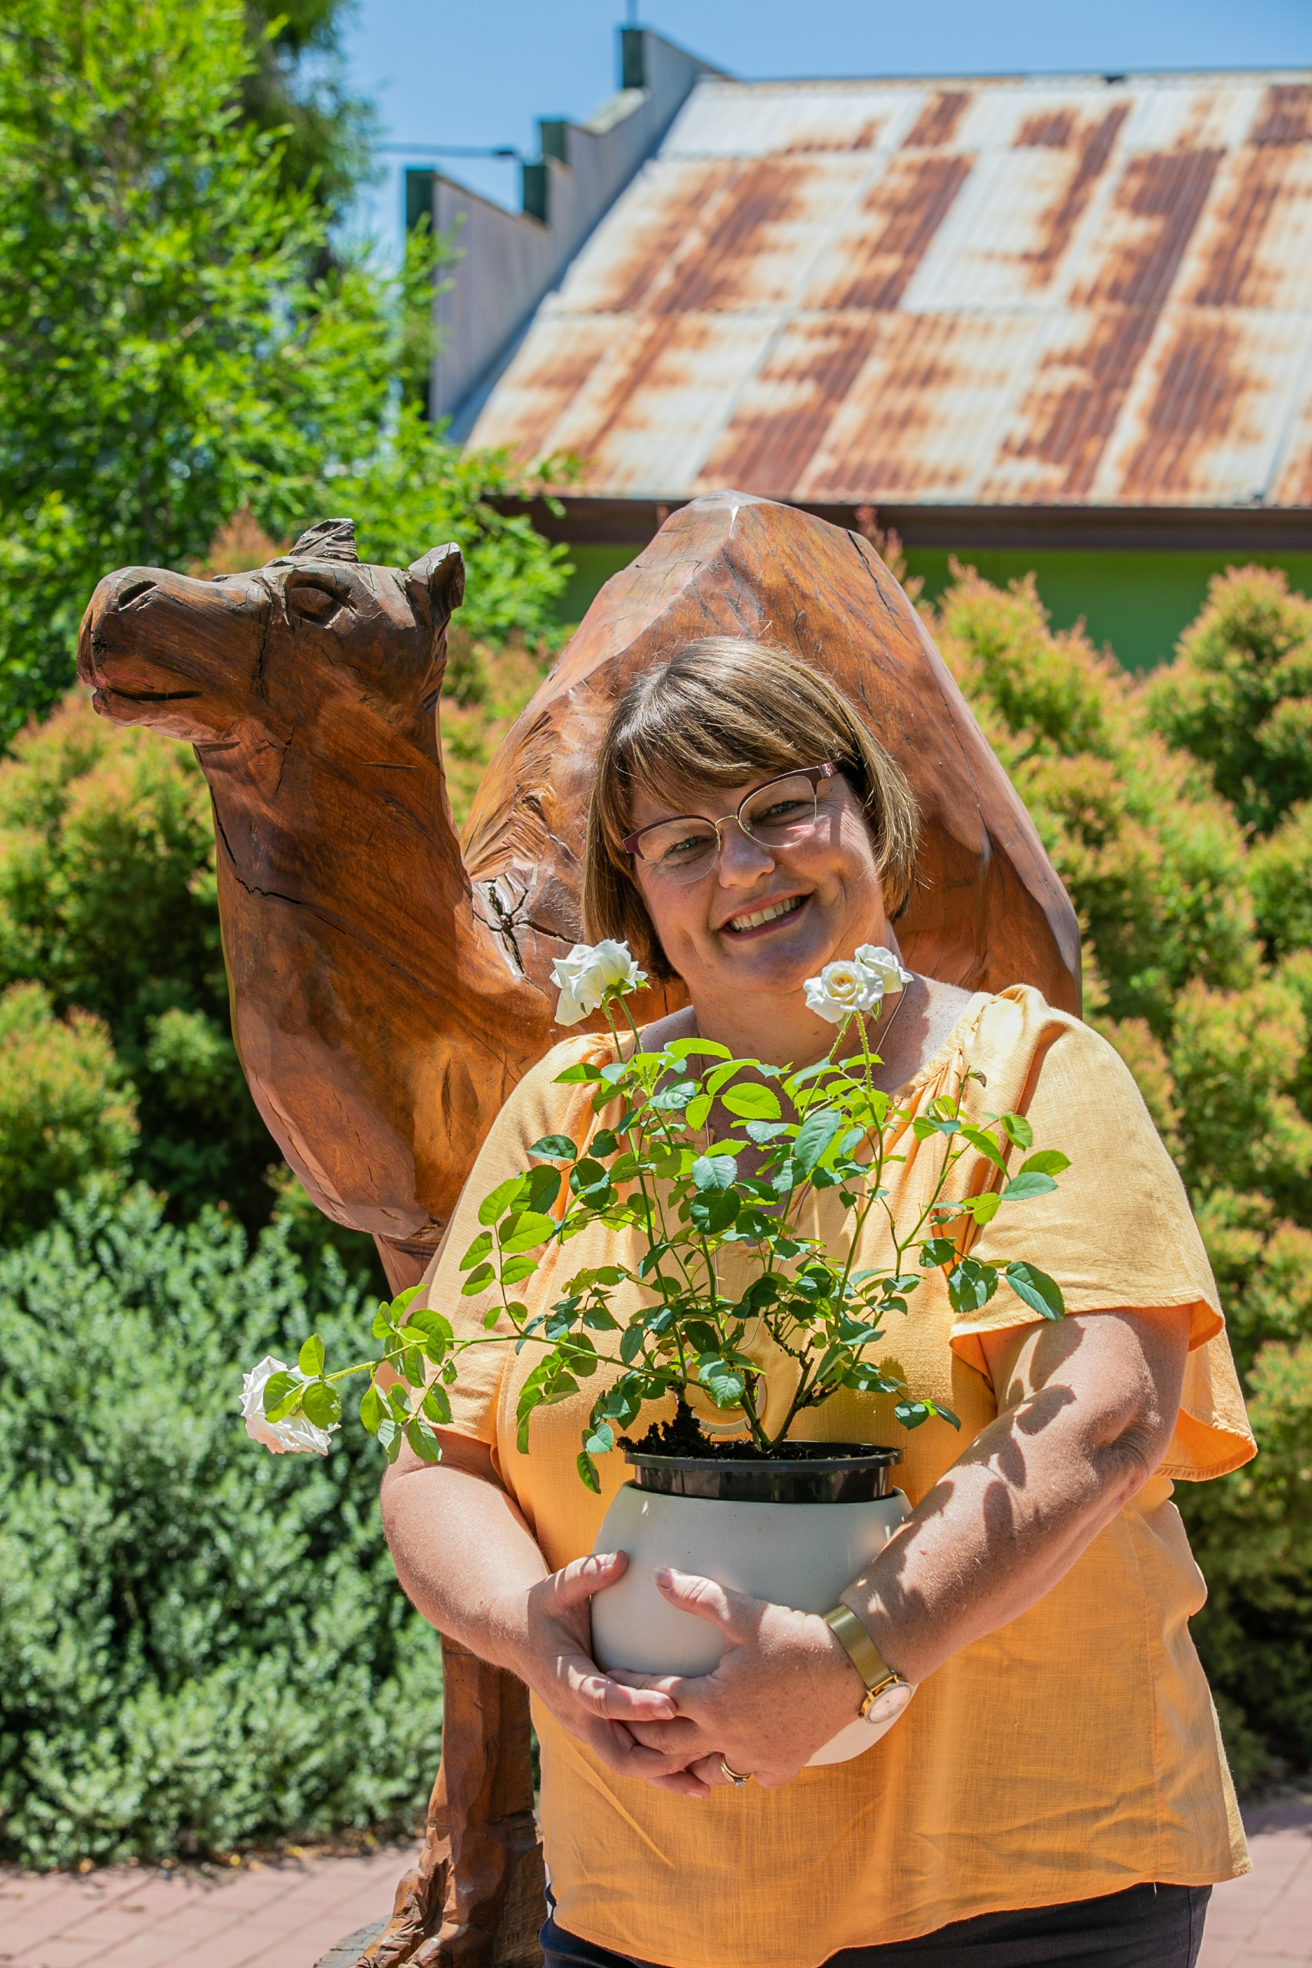

“[Insert Relevant Quote or Story from Council]”

4.2 Housing Characteristics

4.2.1 Dwelling Structures
The majority of dwellings in the region are separate detached houses in 2021 there were 10,732 separate houses in comparison to 887 semi-detached and 101 apartments and 125 other housing structures (see Figure 12) . This shows minimal housing diversity stock in the Western Downs region presenting an opportunity for more housing stock diversity in region to cater to population composition and need. This lack of housing diversity also presents a huge gap in the market for other types of housing stock and mix which presents an investment opportunity in the region.

Figure 11: Number of dwellings by structure type in the Western Downs region
When diving deeper into the mix of dwelling types in the region, it is evident that the majority falls into larger 3-bedroom or 4-bedroom homes with 69.3% of the population occupying this dwelling type (see Figure 12). Between 2016 and 2021 an additional 687 3-bedroom and 4-bedroom dwellings were added to the housing supply in the Western Downs region. In comparison, only 126 additional dwellings with less than 3 bedrooms were added, presenting a challenge with the changing demographics of the region.
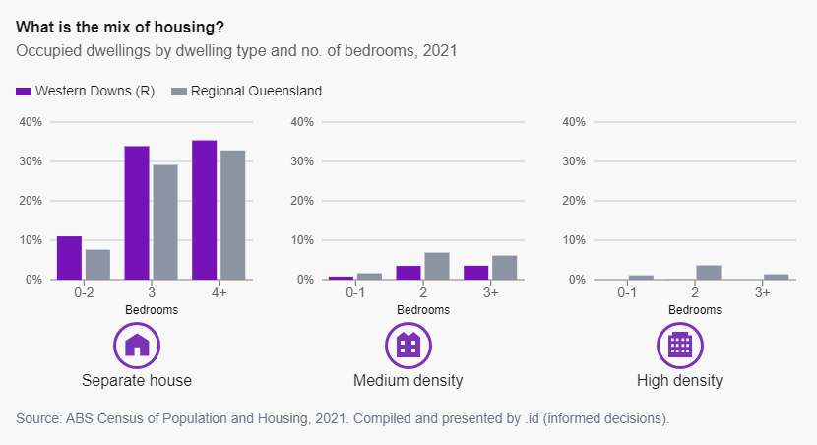
Figure 12: Mix of housing occupancy – separate house, medium and high density
The projected dwelling forecast from the latest 2023 QGSO data set (based on high series population growth), shows projected dwellings required from 15,566 in 2021 to 17,865 in 2046 (see Figure 14). Therefore, a significant increase in housing development is required to accommodate the increase in population, approximately 2,299 new dwellings to accommodate population growth over coming years. Since 2013 approximately 1,753 new dwellings have been built therefore a significant boost of housing supply is required over the coming years to accommodate population growth .

Figure 13: Projected Dwellings in the Western Downs Region under the “High Series”.
Home Ownership
The current home ownership according to latest ABS data indicates that 33.9% of people fully own their own homes, 27.5% owned by mortgage and 32% rented.
Residential Building Approvals
According to the ABS, monthly building approvals show that there was a boom in housing development from 2013 to 2015 and then a steady rate of dwelling supply in the years since. (see Figure 15). A variety of factors, such as high housing demand and high availability of material and labour resources during this boom, and then a consistently challenging housing and land development market and varied demand in the subsequent years
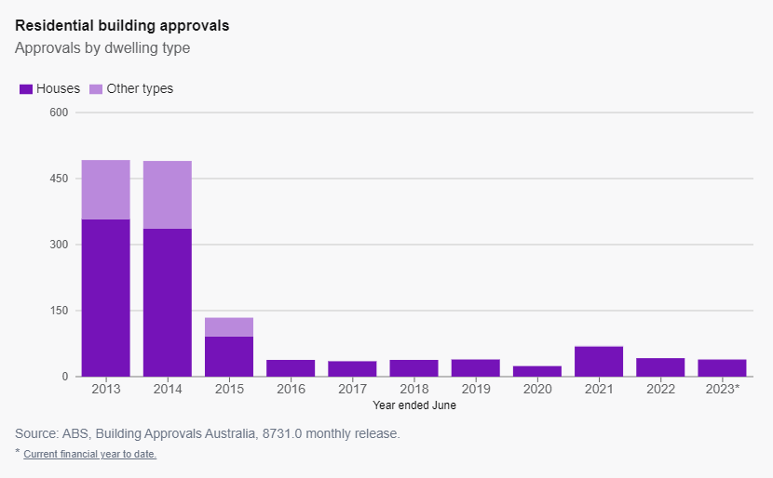
Figure 14: Residential Building Approvals from 2013 to 2023

4.2.2 Private Rental Market
As of December 2022, the overall median house rent in the Western Downs region was $350/week in comparison to the Regional Queensland average of $500/week (see Figure 16). Median unit rental prices sat around $270/week in comparison to $420/week in Regional Queensland..
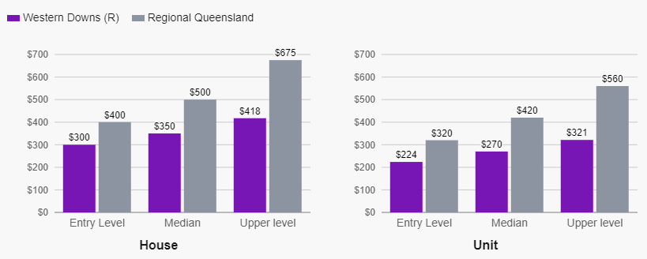
Figure 15: Weekly rental listing prices by price point for quarter ending December 2022

4.3 Western Downs’ Housing Need
Of the 13,484 households in the region, 912 were noted to be in housing stress in 2021. Housing stress is felt in different locations within the Western Downs region (see Figures 17 and 18), with mortgage stress felt most predominately in the area of Tara (14.3% of mortgage households in stress) whilst rental stress is higher within the area of Wambo (21.3% of rental households).
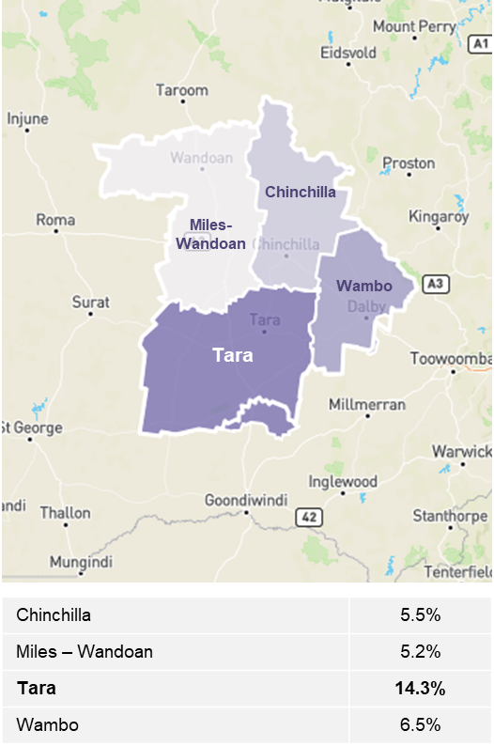  Figure 16: Western Downs areas experiencing mortgage stress | 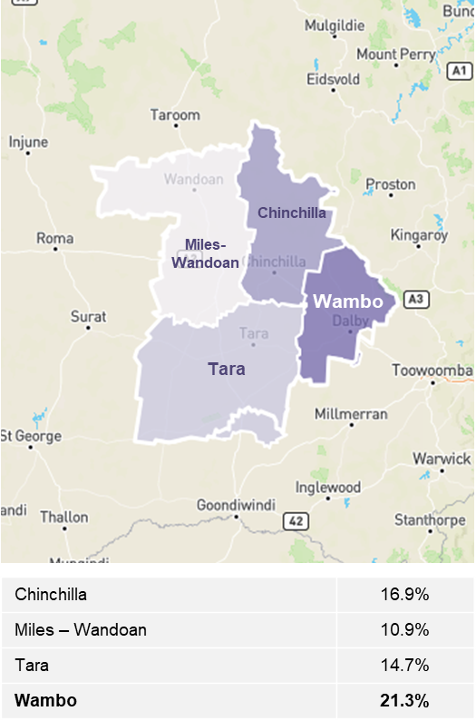  Figure 17: Western Downs areas experiencing rental stress
463 households have an unmet need for affordable housing in the Western Downs region. This represents 3.9% of all households. It is the low-income earners in need of affordable housing the most, as well as lone persons (as illustrated in Figures 18 and 19) . Although housing is considered to be affordable in the region currently, the diversity of housing choice is not available.. This need will increase in the future due to the growth of these household compositions over time .
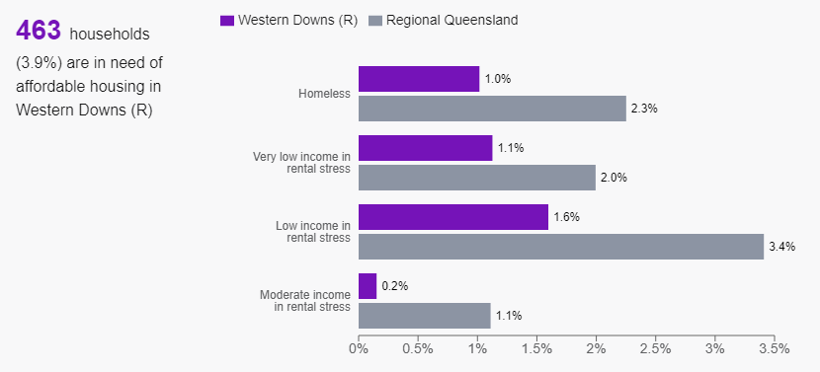
Figure 18: Households in Need of Affordable Housing
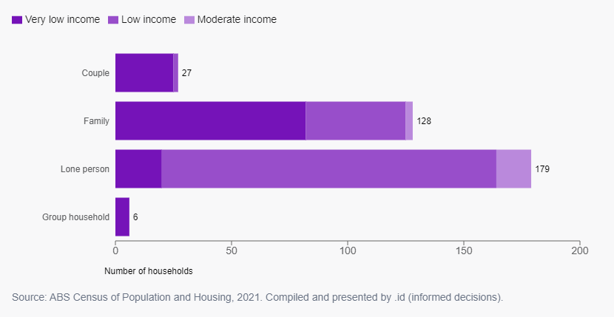
Figure 19: Types of households in need of affordable housing
A combination of the factors described in previous sections of this report, particularly the stagnant supply of affordable housing and increasing demand for more diverse housing options, is resulting in a strong increase in housing prices in the region. As these prices of housing (both rental and mortgages) increase within the region, families under stress will be placed under increasing pressure, meaning many of the numbers presented will likely increase.
Further data and information can be found on housing need and stress on the Western Downs Housing ID Monitoring Dashboard.

4.4 Barriers to New Housing Supply
Representatives of Western Downs Regional Council have undertaken a brief investigation into housing supply matters with some select market participants in late 2023. The purpose of these investigations was to seek a more accurate understanding of the need for additional supply, and to the barriers to investment in new housing stock in the Western Downs.
- The key reflections from these investigations included:
- Significant construction cost escalations have impacted on confidence, impacted on project viability, project financing and financial returns;
- Some information provided reveals that cost escalation for single detached dwellings has increased by 30% to 40% in three years, and as much as 75% in five years;
- Construction costs are significantly greater in more regional areas when compared to South East Queensland;
- Government costs, including application fees and infrastructure charges may have an impact on viability;
- Cost increases during construction are reducing certainly about subdivision project costs, with resultant difficulties and risks with obtaining financing; and
- Cost increases for dwellings is impacting on confidence and reducing the purchase of the resultant lots.
- Accommodating new employees is particularly difficult:
- Accommodation is now often having to be provided for new employees, for entry level positions through to higher level positions;
- Developers are often looking for the security of long term tenants (for example, via a lease), which may align well to employers needs.
- High housing development costs per sqm.

Construction impediments
- Obtaining skilled tradespeople and labourers difficult for construction projects;
- Staging of projects is often necessary, and staging does not align well to some project types (ie multiple storey developments, or developments with basements); and
- Construction time lags are a risk, especially where costs escalations exist.
- Models for future developments
- Government participation in markets may be necessary,
- Participation could be in the form of feasibility investigations, the underwriting of housing and land packages, offering land for development, provision of trunk infrastructure and direct government grants.

WESTERN DOWNS REGIONAL COUNCIL LOCAL HOUSING ACTION PLAN SEPTEMBER 2023 DRAFT PAGE 22

5.0 Key Focus Areas
Areas of focus have been determined through a review of existing data and engagement with stakeholders and community as identified in the methodology. These focus areas will be considered when identifying and prioritising actions.

5.1 Land and Property
The Western Downs region is currently facing key challenges in a multitude of areas including low availability of land, low housing stock levels, low building approval rates, lack of housing diversity (covered in more detail in the “Housing diversity” focus area), low housing vacancies and resilience.

5.1.2 New Stock
The region is seeing minimal building applications resulting in a slowing (to non-existent) entry of new housing stock (see Figure 21) . Based on anecdotal evidence it is expected that the economic opportunities to invest in the region are not fully understood by both residents and developers. There is a real need within the region to encourage residents and developers with a vision of constructing units or subdividing land to bring more diverse housing stock online.
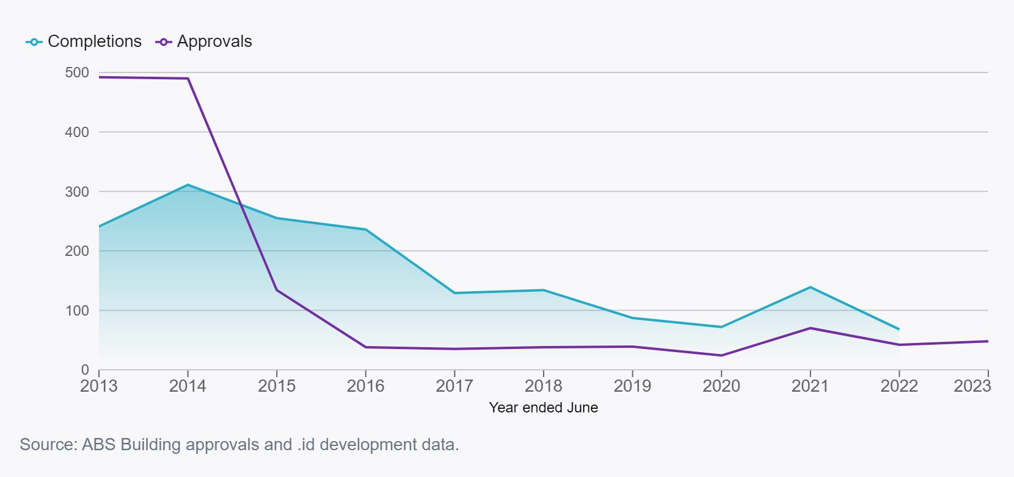
Figure 20: Housing Supply Activity Tracking (Number of New vs Completed)

5.1.3 Existing Stock
Existing stock within the region currently sees some challenges in the space of resilience with a small number of homes being in flood prone areas making them susceptible to future events (such as those in the 2020 flooding event in the region).
Based on local insights, it is expected that the region has several vacant lots of land as well as some vacant dwellings in the region. A more detailed review would be required to obtain detailed numbers; however, this demonstrates a possible opportunity to review policies and incentives to utilise stagnant stock. Additionally, through engagement across community stakeholders, it has been identified that other opportunities may lie in working in partnership with community housing groups to identify underutilised council land to provide suitable social and affordable housing.
When looking at the rental stock within the region, local real estate agents are describing a large reduction in the rental book with recent drops from 750 to 400. Key drivers of this issue include the increase of owner-occupiers (i.e. people are moving into their investment properties) and fewer retirees moving to the coast due to affordability constraints.
Table 1 below provides a summary of the drivers and impacts identified for the focus area of land and property.
Table 1: Summary of key drivers and impacts for land and property.
Key Focus Area: Land and Property
Drivers | - Land availability in the region (particularly in Dalby) is low.  - Level of vacant land and vacant households is an area requiring further investigation, however, could be an area of untapped potential.  - Low attraction of investors / developers to the region demonstrated by the decline in residential building approvals.  - Lack of coordination across government on major projects requiring workforce to map housing needs.  - Builder shortages experienced both in the region and more broadly slowing progress of the low number of building approvals.  - Future projects potentially seeing a large influx of workers needing accommodation and taking up residential stock.  - Relative affordability within the region (and lack of affordability in other regions) is seeing owners of investment properties returning to be owner occupiers.  - Lack of funding to improve resilience of existing housing stock.
Impacts | - Affordability of available housing and rental stock threatened due to increase demand from non-residents.  - Availability of new stock suitable for changing demographic needs and additional migration due to a lack of investment and development as well as lack of builders.  - Availability of existing stock with new projects’ workforce taking up residential stock from the overall community often leading to people needing social housing or, at times, becoming homeless.  - Missed opportunities to work in partnership between State and Local Government to have a joint approach to project approvals and fulfilling housing needs.  - Shrinking of rental stock due to displacement from owner occupiers in rental stock.  - Households are not able to increase the resilience of their existing properties resulting in risk.

5.2 Housing Diversity
As demonstrated by the data presented, the Western Downs region, although relatively affordable when compared to Regional Queensland, currently has limited choice when it comes to housing types. The current dwelling types do not meet the needs of a the increasingly diverse future demographic.
With the growing opportunities for work and relative affordability, both single and smaller families will be attracted to the region, calling for a variety of different housing types needing to be made available. This increased diversity will be important to ensure that current residents are able to continue to afford their current homes and strengthen the community fabric.
Despite the demographic changes of the region there is challenges to build dwelling types such as smaller houses, duplexes, multiple unit developments and secondary dwellings. There is the opportunity to invest in these housing types in the Western Downs region. Table 2 below provides a summary of the drivers and impacts identified for the focus area of housing diversity.
Table 2 3: Summary of key drivers and impacts for Housing Diversity
Key Focus Area: Housing Diversity
Drivers | - Projected shift in household compositions in the region, with an expected increase of younger single person, smaller families and consideration of aged care and homes for aging population.  - Housing mix within the region is predominately larger 3-to-4-bedroom homes.  - Developers and banks are averse to supporting the development of smaller mixed-use homes within the region due to lack of precedent.  - Ageing demographic who will require more appropriate housing options to better accommodate their specific needs.
Impacts | - Availability of new stock that is suitable for changing demographic needs and additional migration is low due to a lack of investment and development as well as lack of builders.

5.3 Workers Accommodation
Growth patterns and cycles in the resources and energy industry can place significant pressure on the housing market, particularly in regional and remote areas. Noting the Queensland Energy and Jobs Plan and the potential heavy reliance on Western Downs to deliver Renewable Energy projects it is expected that significant pressure will be placed on accommodation needs in the region.
The Western Downs region also has a thriving Agricultural industry that employed 2,805 FTE workers in 2022 (see Figure 20). The Agricultural sector is projected to continue to grow in the region support jobs over the next decade.

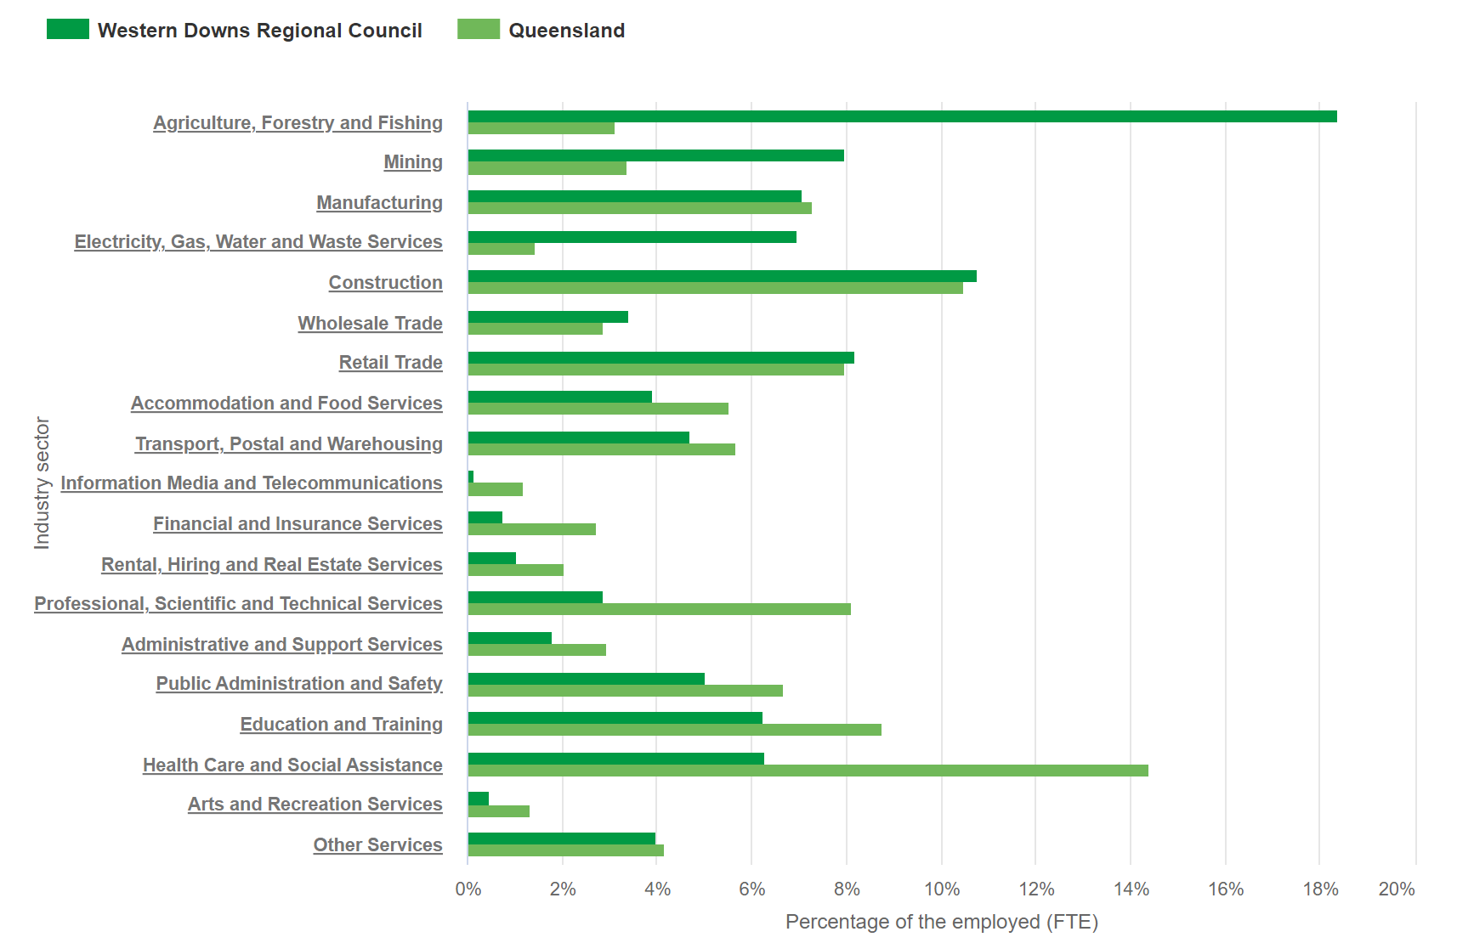
Figure 21: Employment (FTE) 2021/2022 by Industry Sector in Western Downs compared to Queensland
Overall, jobs available in region are expected to grow from 22,780 currently to 27,780 in 2030. This is an overall 22% growth in jobs over the next 10 years. With such a low unemployment rate, it is expected that Western Downs will see a significant proportion of jobs filled by workers outside of the region. Currently approximately 4,140 workers are located outside of the Western Downs. This dependence on workers outside the region is expected to increase over time, with around 7,788 workers from outside of the region expected to fill jobs in 2030 (28%). ￼
This growth is already evident with expanding energy, resource, intensive agriculture, heath and aged care and government sectors all experiencing local growth.
The Western Downs Regional Council has long promoted a 'live local' policy, encouraging resource workers to permanently live in the region, rather than in on-site camps. Noting that this may not always be possible there is a need to consider providing workers accommodation or camps within towns, rather than remote camps to enable participation in the community.
The Western Downs region is also expected to experience workforce gaps across all industries, with the construction industry expected to experience the largest increase of the local skills gap – rising from 45% to around 60% by 2030.
Each of the Mining, Rental, Hiring and Real Estate and Electricity, Gas, Water, and Waste Service industries are estimated to have gaps of over 60% of total workforce demand.
The largest workforce gap is predicted to be in Mining, with a gap of 73% of total demanded workforce in 2030. When assessing the magnitude of the skills gap it is also important to consider the impact that some of the small gaps may have on the liveability of the region. Health Care and Social Assistance, Education and Training, and Retail Trade all have local skills gaps, ranging from 10% to 14%. However, even small gaps in these essential services can act as incredible barriers to attracting workforce to the region. Essential workers in the Health Care and Social Assistance industries are showing the highest growth, rising from 6% to 14% over the decade. This represents a large gap for the region in having people with the appropriate skills to fill these places.
With thegrowing workforce and migration into the region, pressures will be felt in being able to cater to an increased non-resident worker population requiring accommodation that differs from the current housing mix available. Table 4 provides a summary of the drivers and impacts associated with the focus area of workers accommodation.

Table 4: Summary of key drivers and impacts for Workers Accommodation
Key Focus Area: Workers Accommodation
Drivers | - Growing workforce and migration numbers into the region for upcoming energy job opportunities and growing Agricultural sector.  - Housing mix within the region is predominately larger 3-to-4-bedroom homes with low vacancy rates.  - Transient nature of workers to the region to deliver large scale projects and seasonal agricultural work.
Impacts | - Affordability of available housing and rental stock due to increase demand from non-residents and their respective higher median income than residents.  - Community fabric at risk due to the transient nature of workers to the region and/or the segregation of new workers through establishment of camps.  - Tourism sector benefits by having low vacancy rates due to workers in the region booking accommodation longer term. This, however, causes low accommodation vacancy for tourists visiting the region, requiring new accommodation to be attracted that focuses on tourism rather than workforce.  - Skills gaps experienced and regional growth placing further pressures on key services (e.g. Healthcare and Social Services).

5.4 Social Housing
There is a high demand for social housing across Queensland and allocations are focussed on supporting households with the highest need. Weekly median household incomes in the Western Downs region are $1,374 compared to the Queensland median of $1,675.
There are currently 250 social housing dwellings (92 provided by Community Housing) in the Western Downs region. In June 2023 there were 164 people registered for social housing who had Western Downs as one of their preferences. Emergency responses during 2022 and 2023 have resulted in fluctuating and varied needs for social housing and crisis accommodation across the townships of the region.
Since 2021 there over 164 applicants on a register of need list and the average applicant has 1.66 people in the household as part of the application. According to the Census in 2021, 121 persons were sleeping rough in the region .
Anecdotal evidence suggests that homelessness is on the rise on the Western Downs, with 121 people noted as sleeping rough in the Western Downs in the 2021 census.
The council’s community division carried out investigations in the six principal towns through conversations with various community groups, Chambers of Commerce and Industries, and local individuals involved in community work. These investigations found there is acute housing stress in Tara, and limited availability of rental housing throughout the region.

5.5 Cohort Specific Housing

5.5.1 First Nations
All First Nations peoples in Queensland should have a safe and secure home that meets their housing, locational and cultural needs, and provides the foundation for First Nations families and communities to thrive. However, Aboriginal and Torres Strait Islander Queenslanders still face significant housing challenges. Inroads are being made, with Aboriginal and Torres Strait Islander Queenslanders now having the highest life expectancy among Australia’s First Nations peoples.
The Western Downs region has a higher proportion of Aboriginal and Torres Strait Island Peoples when compared to the State who represent the diverse groups of the Barunggam, Iman (Yiman), Bigambul, Wakka Wakka and Jarowair peoples. There are currently a number of strong and active First Nations service providers in the local area, including Goondir Health Services. Recognising the fundamental right of Aboriginal and Torres Strait Islander peoples and communities to determine the pace, shape and manner of change and decision-making at all levels, it is important that council engages with members of the community in addressing housing. Working to provide culturally appropriate dwellings and housing opportunities.
Understanding the need for a considered approach to identifying needs and opportunities for First Nations housing, more detailed information on the needs of these communities will be included in future iterations of this plan.

5.6 Improved Data and Analysis of Need
It is clear that a key limitation in relation to the next steps for this Local Housing Action Plan and the provision of housing supply, is clear and unambiguous data.
Information regarding housing availability, housing needs, homelessness and workforce housing gaps needs to be improved and published widely to inform high quality decision making on housing supply. Several of the key action items in this Housing Action Plan charge government agencies with these actions, and the sharing of this information widely will be necessary for the success of this plan.

6.0 Response Opportunities
A Local Housing Action Plan enables engagement across all levels of government, and benefits from partnerships between private and not-for-profit organisations. An initial set of tactical actions has been developed, enabling refinement through an ongoing iterative process. These actions provide for a targeted response and outcomes that will seek to either create immediate benefit or establish a foundation for the next phase of actions. More specific responses can then be determined that provide flexibility in delivery and support each of the broad areas identified.

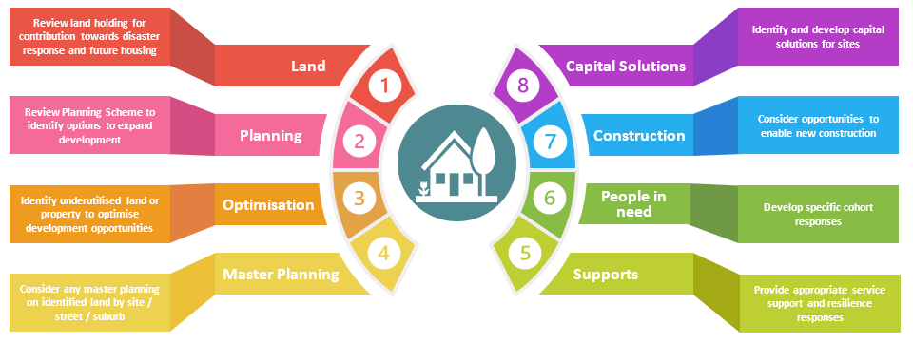

6.1 Actions
The Council with the support of the Queensland Government through the Housing and Homelessness Action Plan 2021-2025 is committed to engage in the delivery of its initial Local Housing Action Plan through this set of actions, developed to target immediate to longer term housing responses. This is an iterative process, and these actions and target outcomes will seek to either create immediate benefit or to establish foundations that help respond to ongoing housing need.
□ | Land and Development Priority Actions | State Agency Lead / Support | Targets | Timeline  Starting in December 2023
1.1 | State Government agencies to undertake an audit on available land to identify potential building needs or opportunities to reallocate existing and underutilised housing stock to social or affordable rental properties. | - Western Downs Regional Council,  - Department of Housing and Communities | - Increased utilisation of available land | Quarter 1 2024
1.2 | Council will continue to dispose of land that was identified as surplus at the Ordinary Meeting on 13 January 2023, and sell the land in a phased and controlled way to avoid damaging markets. | - Western Downs Regional Council | - Increased utilisation of available land | A staged approach across 2024 to minimise market impacts
1.3 | Council to promote opportunities for private property owners to obtain assistance from QRA Resilient Homes Fund to facilitate the improvement of flood resilience of existing housing stock within flood prone areas. | - Western Downs Regional Council | - Improved awareness of programs to improve resillence of existing dwellings | Quarter 2 2024
1.4 | Following the completion of an updated Flood Study, Council will investigate opportunities for mitigation projects that can lessen the impact of major flood events. | - Western Downs Regional Council | - Council determines whether any mitigation projects are pursued | Quarter 4 2024
1.5 | Council to strongly encourage and advocate to attract private sector investment in conventional subdivisions and dwellings to meet high demand in key areas (i.e., Dalby, Chinchilla, Tara and Miles) as identified in the Economic Development Strategy 2023 – 2028. Council will also advocate for improved access to finance and insurance for these priority developments. | - Western Downs Regional Council  - Private Sector Investment | - Increased housing supply and diversity of supply.  - Rental vacancy above 2% | Quarter 1 2024
1.6 | Council to continue to work with the State Government on the redevelopment of the former Caravan Park site, Milne Street Tara, for emergency accommodation. | - Western Downs Regional Council | - Increased housing supply and diversity of supply. | Completed, as project was accelerated due to October 2023 Tara Bushfires
1.7 | Through an expression of interest process, Council will offer surplus residential land in Tara (off Haddock Place) to the market for sale, targeting proposals that deliver affordable housing development proposals. | Western Downs Regional Council | - Increased housing supply and diversity of supply | Quarter 1 2024
1.8 | Council to consider mixed-use development at the now vacant land at 107Drayton St, Dalby. | - Western Downs Regional Council | - Increased housing supply and diversity of supply  - Rental vacancy above 2% | Quarter 1 2024

□ | Planning Priority Actions | State Agency lead/support | Target | Timeline  Starting in December 2023
2.1 | Council to review planning scheme to improve housing diversity within the region. Opportunities for review could include:  - Allowance of housing development on Rural Residential lot sizes smaller (e.g. 2,500m²)  - Allowance of housing development on Low Density Residential lot sizes smaller  - Lot size diversity house and land size requirements in various locations to match land constraints with dwelling need and types.  - Expansion of Medium Density Residential Zone to allow further areas to develop. | - Western Downs Regional Council | - Increased housing supply and diversity of supply.  - Rental vacancy above 2% | Quarter 1 to 4 2024

□ | Optimisation Priority Actions | State Agency Lead/Support | Target | Timeline  Starting in December 2023
3.1 | Council to amend the current Housing Land Incentive Policy to increase take up of this incentive and to assist with the viability of highly demanded residential developments. | - Western Downs Regional Council  - Private Sector Investment | - Increased housing supply and diversity of supply.  - Rental vacancy above 2% | Quarter 1 2023
3.2 | Investigate and incentivise utilisation of ‘vacant’ houses as included in the Economic Development Strategy 2023 – 2028. | - Western Downs Regional Council  - House owners | - Increased occupancy | Quarter 2 2024
3.3 | All State Agencies with presence in the Western Downs will prepare a comprehensive assessment to ensure each agency has sufficient housing to meet community needs. Where necessary, new housing stock shall be provided in areas with extreme housing shortages | - Western Downs Regional Council  - Queensland Government | - Reduced housing stress | Quarter 1 and 2 2024
3.4 | Council to continue to advocate to State agencies (especially Coordinator General) that as part of any development approval process for large scale developments, that the proponents are properly investigating housing needs, and to prioritise opportunities to consider new housing stock or Workforce Accommodation within town centres to accommodate temporary influx of workers with new projects. | - Western Downs Regional Council  - Queensland Government | - Increased temporary accommodation | Ongoing from Quarter 1 2024
3.5 | Council to investigate funding partnerships with not-for-profit social housing providers to deliver short term outcomes for specific cohorts in the interim with longer term plans being incorporated. | - Western Downs Regional Council  - Housing Providers | - Reduced housing stress | Quarter 2 2024, in the context of 2024/25 Council budget
3.6 | State and Federal Governments to provide more available funding to go to Western Downs for the purpose of constructing new social and affordable housing, in line with data of social housing need. | - State and Federal Housing Departments | - Reduced housing stress | Quarter 1 and 2 2024, in the context of 2024/25 budgets
3.7 | In partnership with local service providers and State agencies to better coordinate the collection and analysis of social housing data, including highest need, homelessness and for each locale within the region. | - Queensland Government | - Increased evaluation and reporting on housing issues. | Quarter 1 and 2 2024

□ | Master Planning Priority Actions | State Agency lead/support | Target | Timeline  Starting in December 2023
4.1 | Through an LGIP review process, Council will investigate opportunities to extend trunk networks for sewer/water to large parcels of Low-Density Residential land in the western corridor of Dalby to help to facilitate development. | - Western Downs Regional Council | - Increased land availability | Quarter 1 to 4 2024

□ | Supports Priority Actions | State agency lead/support | Target | Timeline  Starting in December 2023
5.1 | Council to consider opportunities for additional resourcing and employee housing to staff accommodation to support the increases in development and development applications. | - Western Downs Regional Council | - Increased housing supply and diversity of supply.  - Rental vacancy above 2% | Quarter 1 and 2 2024
5.2 | Council to advocate to the development industry the opportunities for developing a range of aged care accommodations in the region, including Over 50s type developments as well as higher care facilities. | - Western Downs Regional Council  - Aged care providers | - Increased housing supply and diversity of supply.  - Rental vacancy above 2% | Ongoing from Quarter 1 2024

□ | People in need Priority Actions | State agency lead/support | Target | Timeline  Starting in December 2023
6.1 | Council to investigate needs of future youth housing due to address expected skills gap in Western Downs then working with State to identify suitable intervention pathways. | - Western Downs Regional Council  - Queensland Government | - Increased housing supply and diversity of supply.  - Rental vacancy above 2% | Quarter 1 and 2 2024
6.2 | Council to investigate further opportunities to engage first nations people in terms of housing needs across the region and work with existing FN Housing Providers | - Western Downs Regional Council  - Aboriginal and Torres Strait Islander Peoples | - Increased housing supply and diversity of supply.  - Rental vacancy above 2% | Quarter 1 and 2 2024
6.3 | State funded housing providers who operate in the Western Downs area undertake a needs assessment to determine opportunities to deliver more crisis accommodation in the region | - Western Downs Regional Council  - Service providers | - Reduced housing stress. | Quarter 1 and 2 2024, in the context of 2024/25 budgets

□ | Construction Priority Actions | State Agency lead/support | Target | Timeline  Starting in December 2023
7.1 | Council in partnership with industry to allow alternative housing designs to be constructed within the region. | - Western Downs Regional Council | - Increased housing supply and diversity of supply.  - Rental vacancy above 2%

□ | Capital solutions | State Agency Support/Lead | Target | Timeline  Starting in December 2023
8.1 | Council to promote the Dalby CBD development investment prospectus to encourage development partnerships for a cohesive, contemporary town centre to attract more homes to be built in the region. | - Western Downs Regional Council  - Landlords | - Increased housing supply and diversity of supply.  - Rental vacancy above 2% | Quarter 1 2024
8.2 | Council to investigate opportunities to attract more builders to the region through incentives as part of the business attraction plan, as included in the Economic Development Strategy 2023 – 2028. | - Western Downs Regional Council | - Increased number of builders in region | Quarter 1 and 2 2024

It is important to note that this Local Housing Action Plan provides an overview of available information as a basis for discussion and decision making. It should not be viewed in isolation but considered as part of broad response to supporting housing need across both the Western Downs region and the State more broadly.

6.2 Next Steps
A working group of key representatives from Western Downs Regional Council and select State Government agencies will progress actions, review findings, report quarterly and develop and test next steps.

Australian Bureau of Statistics, Regional Population Growth, Australia, June 2022
Australian Bureau of Statistics, Regional Profile Western Downs, 2021
Australian Bureau of Statistics, Census All persons QuickStats, latest release 2021
Id (Informed Decisions), Queensland Government Western Downs Regional Council, Rental and Mortgage Stress, March 2023.
Id (Informed Decisions), Queensland Government Western Downs Regional Council, Rental and Mortgage Stress, March 2023.
Id (Informed Decisions), Queensland Government Western Downs Regional Council Population and household forecasts, 2021 to 2046, March 2023.
Id (Informed Decisions), Western Downs Regional Council Population, and household forecasts, 2021 to 2046, March 2023.
Australian Bureau of Statistics, Census of Population and Housing, Western Downs, 2021 edition.
First Nations People, Welcome to Country and Acknowledgment of Traditional owners, First Nations People Western Downs Regional Council (wdrc.qld.gov.au)
Id (Informed Decisions), Queensland Government Western Downs Regional Council Population and household forecasts, 2021 to 2046, March 2023.
Australian Bureau of Statistics, 2021 Census All persons Quick Stats, 2021 edition.
Australian Bureau of Statistics, 2021 Census All persons Quick Stats, 2021 edition
Australian Bureau of Statistics, Data Set Household Composition (multiple series 2011 to 2046), 2021 edition.
Australian Bureau of Statistics, Data Set Household Composition (multiple series 2011 to 2046), 2021 edition.
Prices & Incomes | Western Downs Regional Council | housing monitor (id.com.au)
Prices & Incomes | Western Downs Regional Council | housing monitor (id.com.au)
Housing ID, Western Downs, Housing Monitor, Prices & Incomes | Western Downs Regional Council | housing monitor (id.com.au)
Id (informed Decision), Population and household forecast 2021 to 2036. March 2023.
Id (Informed decision), Western Downs Population and household forecast 2021 to 2036, March 2023.
Id (Informed decision), Western Downs Population and household forecast 2021 to 2036, March 2023.
Australian Bureau of Statistics, Census of Population and Housing, Western Downs, 2021 edition.
Australian Bureau of Statistics, Census of Population and Housing, Western Downs, 2021 edition.
Id. (Informed decisions), Australian Bureau of Statistics, Western Downs Labour Force Survey, March 2023
Australian Bureau of Statistics, Census of Population and Housing, Western Downs, 2021 edition.
Australian Bureau of Statistics, Census of Population and Housing, 2021 edition.
Australian Bureau of Statistics, Population and Housing Projects, 2021 edition.
Australian Bureau of Statistics, Population and Housing Projects, 2021 edition
Id (Informed Decision), Western Downs housing mix, informed by 2021 ABS.
Queensland Government Statisticians Office, Queensland Government Household and dwellings projection, August 2023.
Australian Bureau of Statistics, Building Approvals Australia (monthly release), 2023
Id (Informed Decisions), PropTrack (REA group housing listings, updated twice annually), 2023.
Id (Informed Decisions), ABS Census of Population and Housing, 2021.
Id (Informed Decisions), ABS Census Data Population and Housing, 2021.
Id (informed decisions), ABS Estimating Homelessness 2021 and ABS Census 2021, 2021 editions.
Id (informed decisions), ABS Estimating Homelessness 2021 and ABS Census 2021, 2021 editions
Id (Informed Decisions), ABS Building approvals and .id development data, 2023.
Id (Informed Decisions), ABS Building approvals and .id development data, 2023.
National Institute of Economic and Industry Research (NIEIR), compiles and presented in economy id. by .id (informed decisions), 2023
Deloitte, Western Downs Workforce Gap Analysis, August 2021.
Queensland Government, Social Housing Register Data Western Downs, 2023.
Queensland Government, Social Housing Register Data Western Downs, 2023.
Australian Bureau of Statistics, Population and Housing Data, 2021 edition.

